# ZBF jednoducho

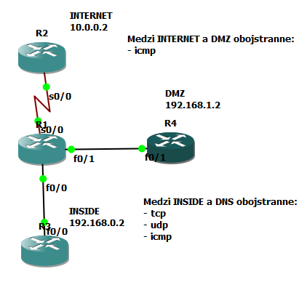

Zabezpečené smerovanie medzi všetkými zariadeniami staticky

# R1

!

class-map type inspect match-any VONKU

match protocol icmp

class-map type inspect match-any DO-DMZ

match protocol tcp

match protocol udp

match protocol icmp

!

policy-map type inspect INTERNET-DO-DMZ

class type inspect VONKU

inspect

class class-default

policy-map type inspect INSIDE-DMZ

class type inspect DO-DMZ

inspect

class class-default

!

zone security INTERNET

zone security DMZ

zone security INSIDE

zone-pair security INSIDE-TO-DMZ source INSIDE destination DMZ

service-policy type inspect INSIDE-DMZ

zone-pair security DMZ-TO-INSIDE source DMZ destination INSIDE

service-policy type inspect INSIDE-DMZ

zone-pair security INTENET-DO-DMZ source INTERNET destination DMZ

service-policy type inspect INTERNET-DO-DMZ

zone-pair security DMZ-DO-INTERNET source DMZ destination INTERNET

service-policy type inspect INTERNET-DO-DMZ

!

interface FastEthernet0/0

ip address 192.168.0.1 255.255.255.0

zone-member security INSIDE

!

interface Serial0/0

ip address 10.0.0.1 255.0.0.0

zone-member security INTERNET

clock rate 64000

!

interface FastEthernet0/1

ip address 192.168.1.1 255.255.255.0

zone-member security DMZ

!

ip route 0.0.0.0 0.0.0.0 Serial0/0